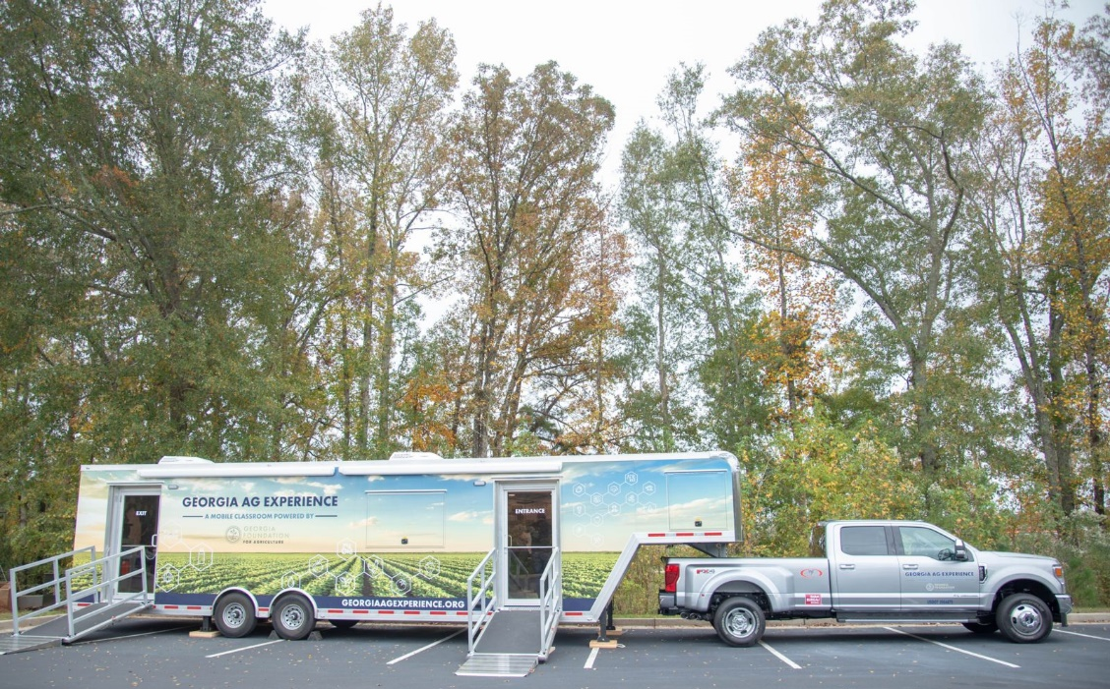
3-5th grade parents and students… we have some exciting news for you! Drum roll please… the Georgia Ag Experience is coming to a school near you! The Georgia Ag Experience mobile classroom will be at __________________ on _______ during the school day. Students will complete a pre-visit lesson with their class and then have the unique opportunity to experience Georgia agriculture in an exciting way! The Georgia Ag Experience integrates agriculture into the classroom in an exciting STEM format! We are so excited to give your students this experience & cannot wait to see you on visit day!

